# Aboriginal stone arrangements

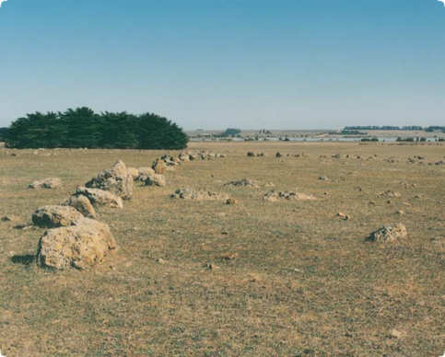

Stone arrangement, Lake Bolac

**What are Aboriginal stone arrangements?**

Aboriginal stone arrangements are places where Aboriginal people have positioned stones deliberately to form shapes or patterns. The purpose of these arrangements is unknown because their traditional use ceased when European settlement disrupted Aboriginal society. They were probably related to ceremonial activities.

**Where are Aboriginal stone arrangements found?**

Stone arrangements occur where there are plenty of boulders, such as volcanic areas, and where the land could support large bands of people. Surviving stone arrangements are rare in Victoria, and most are in the western part of the state.

**Why did Aboriginal people arrange stones?**

We do not know much about the function of stone arrangements. The traditions linked with the places may have been lost when Aboriginal people were driven from their lands during colonial settlement. It is also

possible that stone arrangements are so old that their purpose had been forgotten even before colonial times.

The age of stone arrangements is difficult to guess. Some may be many thousands of years old. The boulders are arranged in shapes or patterns such as natural features, animals and birds, implements, and supernatural figures or events. Most stones and boulders were set into the ground surface, or soil has built up around them over the years.

If the boulders are moved or disturbed, a depression may be left in the ground.

Such places were probably used for ceremonies and rituals. These may have involved initiations and the passing on of secret lore about the spiritual life of Aboriginal people. Stone arrangements in other parts of Australia, including Tasmania, are known to have been ceremonial.

Large numbers of people could have gathered for ceremonies, but only when there was plenty of food. Daisy yams on the volcanic plains of western

Fact sheet number 10

Characteristics

* The stones and boulders are arranged in patterns or shapes such as large circles, animal shapes, boomerangs and mazes.
* Stone arrangements are usually large, measuring many metres across their width. They use stones in a range of sizes.
* The boulders have been moved to the site.
* Stone tools, animal bones, ochre, pipe clay and charcoal may be found in sediment from the arrangements.
* There may be information about the significance of such places that has been passed down to contemporary tribes.

Plan of Mt Rothwell Stone Arrangement

Victoria, or the eel runs in the rivers and wetlands of coastal Victoria, may have provided good places for large seasonal gatherings.

**What about other stone structures?**

Both colonial settlers and Aboriginal people made stone structures. Settlers built hunting blinds, fish traps, houses, cairns and walls. Colonial structures were generally made from dressed stone and contain European artefacts Aboriginal people also made stone shelters, traps for fish and eels, and hunting blinds. All these stone structures have obvious practical functions, unlike Aboriginal stone arrangements.

**Why are Aboriginal stone arrangements important?**

Aboriginal stone arrangements provide a rare glimpse into the fabric of past Aboriginal society. They are an important link for Aboriginal people today with their culture and their past, particularly with the spiritual and ceremonial aspects of Aboriginal societies.

**Are Aboriginal stone arrangements under threat?**

The stones are long lasting, but their arrangements can be damaged or destroyed. If stones are disturbed, the pattern and its significance may be lost.

Stone arrangements may be quite large and at least one example has been partly destroyed where it lay across the route of a roadway.

Ploughing, brush cutting, logging and large grazing animals can also cause disturbance.

First Peoples – State Relations records the location, dimensions and condition of Aboriginal stone arrangements.

The aim is to have a permanent written and photographic record of this important part of the heritage of all Australians. Management works around Aboriginal stone arrangements, such as stock, weed and erosion control, help preserve the sites for future generations.

**Are Aboriginal stone arrangements protected?**

All Aboriginal cultural places in Victoria are protected by law. Aboriginal artefacts are also protected.

It is illegal to disturb or destroy an Aboriginal place. Artefacts should not be removed from site.

The arrangement places have a high spiritual value to Aboriginal people, so access to some places may require permission from the local Aboriginal community.

**What should you do if you find an Aboriginal stone arrangement?**

Do not disturb the place or remove any material. Check whether the place has the typical characteristics of an Aboriginal stone arrangement. If it does, record its location and write a brief description of its condition. Note whether it is under threat of disturbance.

Please help to preserve Aboriginal cultural places by reporting their presence to First Peoples – State Relations.

**Contact:** Heritage Services  
First Peoples – State Relations  
Department of Premier & Cabinet  
1 Treasury Place, Melbourne VIC, 3002  
Telephone: 1800 762 003  
[Aboriginal.Heritage@dpc.vic.gov.au](mailto:Aboriginal.Heritage@dpc.vic.gov.au)

We acknowledge the Traditional Owners of Country throughout Victoria and pay our respect to them, their culture, and their Elders past and present.

© State of Victoria (Department of Premier and Cabinet) September 2024

The State of Victoria does not guarantee that this publication is without flaw or is wholly appropriate for your purposes. We disclaim all liability for any error, loss or other consequence that may arise from your relying on any information in this publication.

To receive this document in an alternative format, phone **1800 762 003**, email **Aboriginalaffairs@dpc.vic.gov.au**, or contact National Relay Service on **1800 555 660** if required. HTML format is available at **firstpeoplesrelations.vic.gov.au**