|  |
| --- |
| 1. What is the Taungurung settlement agreement? |
|  |

Information about the Taungurung *Traditional Owner Settlement Act 2010* agreement

The Taungurung settlement agreement formally recognises the Taungurung people as the Traditional Owners of parts of central Victoria (the area shown on the map below).

The agreement area covers 8.5 per cent of Victoria and includes almost 11 per cent of Victoria’s public land.

Map of the Taungurung Recognition and Settlement Agreement Area

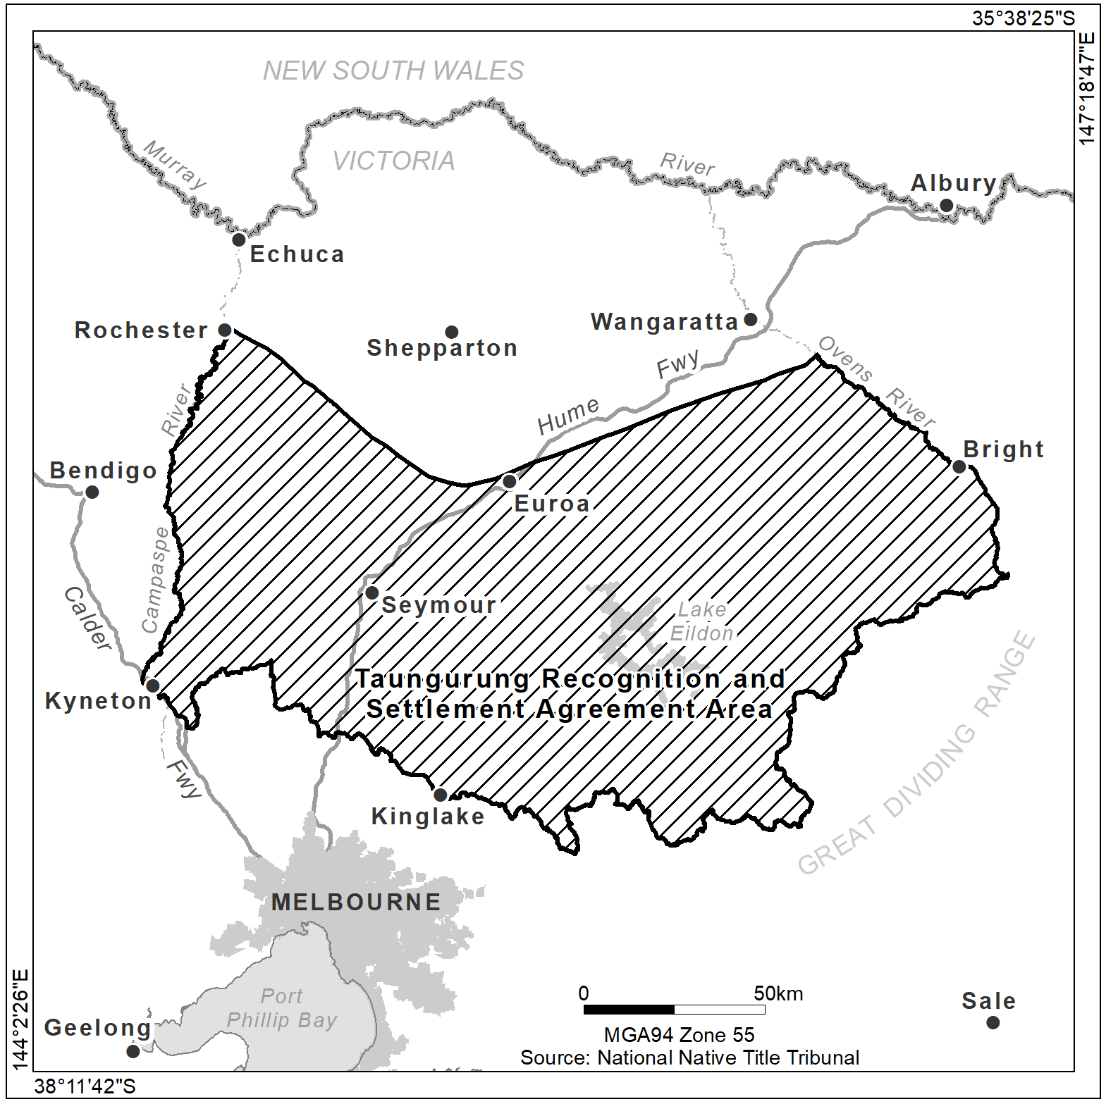

The agreement has been made under the *Traditional Owner Settlement Act 2010* (TOS Act) and related legislation. The agreement is the first native title settlement to be made under the TOS Act without the Federal Court’s involvement. It includes an Indigenous Land Use Agreement (ILUA) registered under the *Native Title Act 1993*.

# What does the agreement include?

The settlement agreement is composed of:

* a Recognition and Settlement Agreement
* a Traditional Owner Land Management Agreement
* a Natural Resource Agreement and Traditional Owner Land Natural Resource Agreement
* a Land Use Activity Agreement, and
* an Indigenous Land Use Agreement.

# What is the financial value of the settlement?

The financial value of the settlement package is approximately $34 million. Of this amount:

* $320,000 was provided to the Taungurung Land and Waters Council Aboriginal Corporation (TLaWCAC) in 2019.
* $25.6 million will be deposited into the Victorian Traditional Owners Trust to be distributed to TLaWCAC over time.
* $7.9 million in the settlement’s first four years is committed for joint management planning and operations, including the establishment of a Traditional Owner Land Management Board with TLaWCAC, and the employment of Taungurung people as rangers.