ABORIGINAL AXE-GRINDING GROOVES

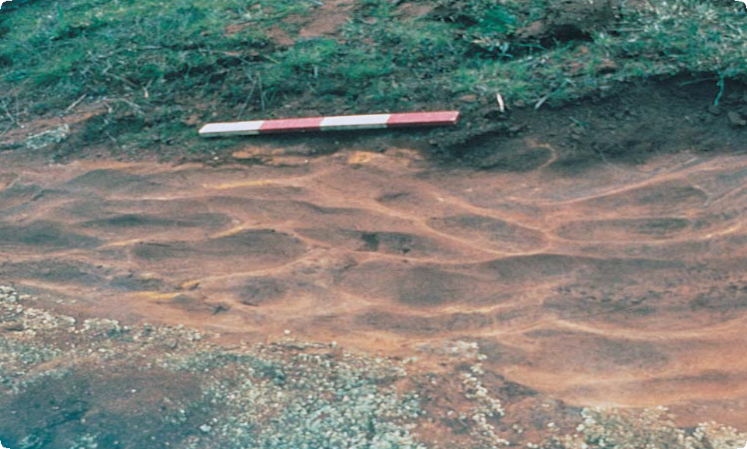

Typical Axe-grinding Grooves Located on a Low Sandstone Outcrop

# What are Aboriginal Axe-grinding Grooves?

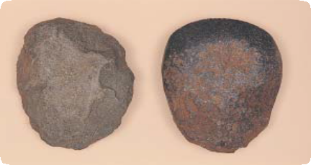

Place Identification

Mini Poster 12

**Characteristics**

* Shallow, oval-shaped grooves indent the surface of sandstone outcrops. The outcrops are usually low and rocky, and the

sandstone has fine, uniform grains.

* The grooves are often in clusters of two to five. They range from 80 to nearly 500 millimetres in length. They can be up to over 200 millimetres wide and 100 millimetres deep.
* Places are generally found near water.

Greenstone Axes before and after Grinding

Axe-grinding grooves are oval-shaped indentations in

sandstone outcrops. Aboriginal people made the grooves when they shaped and sharpened stone axes by grinding them against the sandstone.

Flat, low outcrops of fine-grained sandstone were used to give stone axe heads a sharp cutting edge.

Sometimes, Aboriginal people also carried small pieces of sandstone for sharpening axes, and these portable pieces were often gouged on more than one surface.

Other Aboriginal artefacts are sometimes found near axe-grinding grooves.

**Where are They Found?** Axe-grinding grooves are almost always found along the edges of

rivers, creeks, lakes and swamps,

or near dry or drained water bodies.

# How Did Aboriginal People Produce Axe-grinding Grooves?

Aboriginal people used axe-grinding grooves to finish partly made axes (known as ‘axe blanks’) or sharpen axes that were worn or chipped.

Axe blanks are pieces of stone that Aboriginal people chipped into a basic axe shape at stone quarries and sharpened by rubbing the edges over sandstone. This rubbing action left grooves in the outcrop surface.

Aboriginal people often sprinkled water on the sandstone to make it more abrasive and to reduce dust. This is why the grooves are usually found on outcrops close to water.

# Why are Axe-grinding Grooves Important?

Places of Aboriginal axe-grinding grooves are rare. They provide valuable information about how stone tools were made. They increase our knowledge of past Aboriginal land use and ways of life.

Axe-grinding grooves are an important link for Aboriginal people today with their culture and their past.

# Are Axe-grinding Grooves under Threat?

Sandstone is a relatively soft

stone that is gradually worn by weathering, erosion and trampling by animals such as cows and sheep. Human activities such as mining, road building, damming, clearing, ploughing and construction can also destroy these places.

Aboriginal Victoria records the location, dimensions and condition of Aboriginal grinding grooves. The aim is to have a permanent written and photographic record of this important part of the heritage of all Australians.

Management works around Aboriginal grinding grooves, such as stock and erosion control, help preserve the places for future generations.

# Are Aboriginal Axe-grinding Grooves Protected?

All Aboriginal cultural places in Victoria are protected by law. Aboriginal artefacts are also protected.

It is illegal to disturb or destroy an Aboriginal place. Artefacts should not be removed from site.

# What If You Find Axe-grinding Grooves?

Do not damage or interfere with the sandstone outcrop or remove any material. Check whether the place has the typical characteristics of Aboriginal grinding grooves.

If it does, record its location and write a brief description of its condition. Note whether it is under threat of disturbance.

Please help to preserve Aboriginal cultural places by reporting their presence to Aboriginal Victoria.

Contact:

Heritage Services

Aboriginal Victoria

Department of Premier & Cabinet

1 Treasury Place, Melbourne VIC, 3002

Telephone: 1800 762 003

[Aboriginal.Heritage@dpc.vic.gov.au](mailto:Aboriginal.Heritage@dpc.vic.gov.au)

June 2008

Copyright State Government of Victoria 2008. Authorised by the Victoria Government, Melbourne

ISBN 978-1-921331-63-3

This publication may be of assistance to you but the State of Victoria and its employees do not guarantee that the publication is without flaw of any kind or is wholly appropriate for your particular purposes and therefore disclaims all liability for any error, loss or other consequence which may arise from you relying on any information in this publication.  
<https://www.vic.gov.au/aboriginalvictoria/heritage.html>

cid:4__=45BB09C4DFEFB2D38f9@perimeter.vic.gov.au